Mary, Mother of the Church Saintfield
Open Sun. Tues. Wed. Thurs.10 am – 4 pm
Mon. Fri. Sat. 10 am – 8 pm
MASS
Saturday 6:30 pm
Sunday 11:00 am
Monday, Friday 7:30 pm
Adoration of the Blessed Sacrament
Monday & Friday 7:00 pm
Saturday 12 noon – 6:30 pm

St Joseph’s Church, Carrickmannon
Open Sat & Sun 10:00 am – 2:00 pm
MASS
Sunday 9:00 am
Tuesday 10:00 am
Throats will be blessed
following 10 am Mass

CONFESSIONS
Before Vigil Mass on Saturday

ALTAR SOCIETY
Saintfield – Group 1
Carrickmannon – Team 4
READERS
7/8 February 2026
Vigil: Fionnuala McClure
9 am: Harry Murray
11 am: Monica McGouran
EUCHARISTIC MINISTERS
7/8 Feb 2026
Vigil: Gemma Magennis, John Weston
9 am: Brian Mullan
11 am: James Mullan
Yvonne Younger, Therese Mageean

St Vincent de Paul Society
Telephone:07521463667
Email: stmochai.saintfield@svpni.co.uk
Adoration of the
Blessed Sacrament
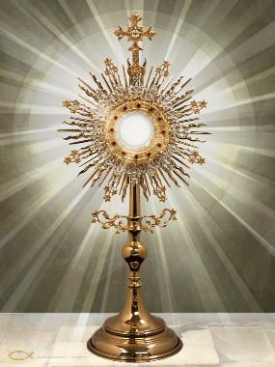
Mary, Mother of the Church
Saturday 7th February
12 noon – 6:30 pm
Do you realize that Jesus is there in the Blessed Sacrament expressly for you, for you alone? He burns with the desire to come into your heart! St. Therese of Lisieux

Please remember in your prayers ++ Recently deceased: John Heaney, James Byrne, Franz Eigel and Kevin Holland.
Anniversaries: Fr John McCarroll, Michael Harrison, Patrick Murray, Martha Lenaghan, Donal Molloy, John Flanagan, Kathleen Murray, John Smyth, Kathleen Halliday and all the Holy Souls in Purgatory.
First Anniversary Mass for Michael Harrison will be offered today in Saintfield Church at 11am.

FEAST DAYS
Monday: The Presentation of Our Lord
World Day for Consecrated Life
Candlemas Day
Tuesday: St Blaise Thursday: St Agatha
Friday: St Paul Miki and Companions
Saturday: St Mel

Every Sunday at 11am Mass
Today we hear about how Jesus went up a mountain and taught his disciples the Beatitudes. Jesus teaches his disciples about the way he would like people to be treated and how he sees some types of people as extra special. He says that they will be happy or blessed.
What could you do to help someone who is sad, or hungry or thirsty?
What could you do to help someone who is being laughed at or picked on for standing up for what they believe in?
Our prayer this week: God of mercy, open our hearts to listen to what Jesus tells us and move us to do what we can to bring these words to life through our actions. Amen.
Today is also the Feast of St Brigid, one of Ireland’s three patron saints. Why not find out more about Brigid or try making your own St Brigid’s cross?

Worksheets and the Kids Bulletin to support this week’s Gospel are available in both churches. Pick up copies for your children/grandchildren.

CHURCH CANDLES SPONSORSHIP
Booklets are now available in both churches if you wish to sponsor the sanctuary candle on any week from 1st February 2026 to 31st January 2027 in memory of family living and deceased.
Candles will be blessed on Tuesday and will be available for home use. £1

Weekly Collection 25th Jan £1241


Monday Social Club
Next meeting
2nd February 2026
12:30 – 2 pm

Crois Dharach CLG Club
Lotto Numbers: 16 18 22 27
No Jackpot winner. Consolation prizes: Phil Sheridan, Gareth McGovern and Lorcan Fairfield. New Jackpot £8100. Tickets available on Klubfunder page, Oaks Bar, Chestnut Bar, Vivo Shop, Dufferin Bar, International & Central Bars Killyleagh.

This year, The St Brigid’s Day Lecture will be given by Fr Tom Layden, S.J. Theme: “The Nicene Creed: A foundation for Ecumenism”, based on Pope Leo XV1’s address at Nicaea. Venue: St Brigid’s Parish Centre, Derryvolgie Avenue, Belfast BT9 6FP, on Sunday 8th February, at 4.00pm.

Down & Connor Diocesan Trust – Vacancy -Vocations Support Officer 20 hours per week to be based within St Colmcille’s Parish, 191 Upper Newtownards Road, Belfast, BT4 3JB. Reporting to the Director of Vocations, the role holder will be required to support, promote and sustain a culture of vocations across the Diocese of Down and Connor. Full details can be found on the Diocesan website at:
http://www.downandconnor.org

Pope Leo XIV Prayer Intention
for February 2026
Let us pray that children suffering from incurable diseases and their families receive the necessary medical care and support, never losing strength and hope.
St Brigid , whose feast we celebrate today, is a figure revered for her profound charity, mercy and dedication to justice, a reverence that transcends generations. Her name is synonymous with healing and care and her charitable deeds were marked by an innate understanding of human suffering. She sought to alleviate it wherever she could. The principles that underscored Brigid’s life were to care for the poor, to lighten everyone’s burden, to comfort the suffering. Brigid and her community took it upon themselves to care for the sick and destitute, embodying Christ-like mercy in their actions.
Brigid’s approach to healing was inseparable from her sense of justice. She did not merely tend to wounds, or weakness, but sought to address the inequalities that left people vulnerable in the first place. Her acts of charity and service echoed Christ’s call in Scripture to love our neighbours as ourselves.
As we celebrate St Brigid’s legacy, may we be inspired to act with the same courage and conviction, ensuring that the vulnerable are not forgotten but cherished and supported. In doing so, we honour not only the memory of St Brigid but also the divine call to love one another as God loves us. Bishop Michael Router

Celebrating 70 years of Faith - St Agnes’ Parish Novena to Our Lady of Lourdes 2026
Beginning 10am Tuesday 3rd Feb - The Call of the Good Shepherd
“I know my own and my own know me”(John 10:14)
Speakers: Jim Deeds, Bridget McNicholl, Paula & Joseph McKeown
Sun: 9.30am & 12.30pm - Mon to Fri: 10am & 7pm - Sat: 1pm & 6.30pm (Vigil)
Penitential Service: Friday 6th Feb 7pm - Mass for the Sick: Sat 7th Feb 1pm
Gathering of Youth: Sunday 8th Feb 7pm

Lent is now fast approaching, a season of reflection, renewal and transformation.
Lenten Series 2026: SYCAMORE Why the name “Sycamore”? Sycamore presents the Catholic Faith in a way that meets the needs of our society today. The series consists of five sessions focused on the renewal of faith and its relevance for all generations today. The Sycamore films - give an inspiring vision of our Catholic faith, thought-provoking testimonies that helps build a sense of Community. “ A great gift from God and just what the Church needs right now”- testimony. It brings people together so they can share ideas, explore their beliefs and think about questions that really matter. This does not mean that you will be asked to talk, you have the opportunity to come along just to listen and hopefully take something away.
Evangelisation begins with an invitation. Who in your life might need this journey? Invite a friend, a family member, or someone who perhaps has been away from Church for a while . This series is for everyone. Please come along!!! To get away from the busyness of life. Make this a commitment for Lent. A sacrifice of your time to listen and reflect. You can enjoy a cup of tea/coffee and light refreshments. All are welcome! To confirm your place please email - noreenkerr3@gmail.com or /saintfield@downandconnor.org
Text 07910537398
Venue: - Sacred Heart Centre, Mary, Mother of the Church, Saintfield
Date: - Commencing Sunday 22nd February for 5 weeks - Time: - 6 - 7.30pm.

Saintfield & Carrickmannon

Parish Bulletin

1st February 2026

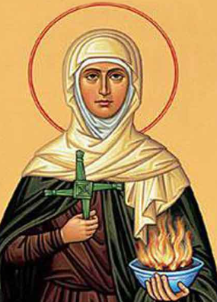
St Brigid
Secondary Patron of Ireland

4th Sunday in Ordinary Time

Fr Michael Sheehan PP 028 9081 2238
Fr Anthony McHugh PE 028 9751 0237
Email: saintfield@downandconnor.org

Spiritual Exercises: 5 Day Silent Ignatian Retreat for Men - Led by Benedictine monks from St. Joseph Abbey, in France. Starts Thursday 30th April (3pm). Benburb Priory, Co. Tyrone €450 (all meals & single room included). Daily Mass - Ordinary Form (Latin & ad orientem). Discover the strength that only comes when you stop running and let God speak. Book at: https://soutenir.clairval.com/retreat-benburb-priory

Marriage Enrichment Weekend, is scheduled to take place from Friday 20th to Sunday 22nd March 2026 at St. Mary’s Retreat Centre, Knock, Co. Mayo. Marriage Enrichment has, for many years, supported married couples in their Sacrament of Matrimony by offering them a sacred space to deepen their relationship, renew their commitment, and grow together through reflection, prayer, and dialogue. To book visit: www.marriageencounter.ie

North Down Museum Bangor
Saturday 7th February
Enjoy a demonstration of St Brigid Cross Making and using the materials provided make your own cross. For more info.visit https://www.visitardsandnorthdown.com/whats-on/celtic-saints-a-journey-through-time-and-tradition-p948071

All bookings for Mass, Month Minds, Anniversaries, Baptisms and Weddings are now to be made through the Parish Office or Parish email address at: saintfield@downandconnor.org. Office Hours: Monday & Wednesday11.00am -1.00pm. Please use the Parish Email outside of Office Hours and we will respond as soon as possible.

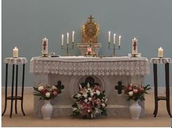

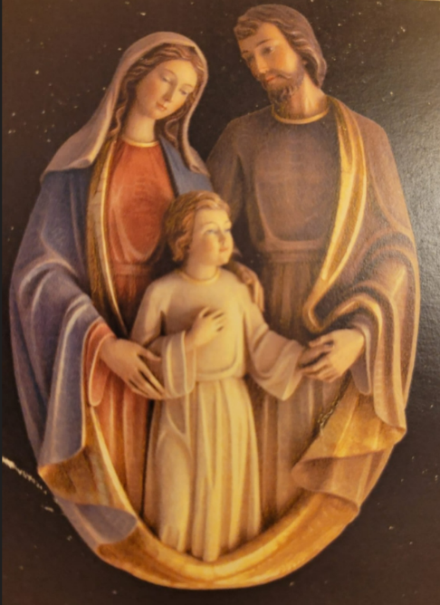

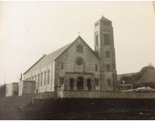

Sunday 1 February - 4th Sunday of Ordinary Time

https://www.scoilmhuireglenties.com/_files/ugd/9347e4_7b9abf4abe264eba914da0e89cde7204.pdf

https://resource-ni.com/wp-content/uploads/2023/01/st.-brigids-feast-day-and-bank-holiday-resources.pdf

At today’s Mass, we hear about how Jesus is baptised by John in the waters of the river Jordan. Water is a very important part of baptism, but it is also really important in our lives for other reasons. We all need water to live. Let’s think this week about all the ways we use water in our lives and about how we can protect our environment by using less water.

Today is also the Feast of St Brigid, one of Ireland’s three patron saints. Why not find out more about Brigid or try making your own St Brigid’s cross?

Our prayer for this week is: St Brigid of Ireland, help us we pray to be kind and loving in our work and play. Amen

Copies of our colouring page and worksheets are available in the church and here is a link to https://thekidsbulletin.com which is also worth reading.

Sunday 8 February - 5th Sunday of Ordinary Time

https://sermons4kids.com/storage/5135/plugged_in_turned_on_bulletin.pdf

Hello children. In the gospel today Jesus tells us that we are light to the world. If we love other people and do what we can to help them, then other people will see how great God’s love is. We will be like the light that shines and is not covered up, so that everyone can see. How will you be like a shining light this week?

Our prayer for this week is: Heavenly Father, thank you for sending Jesus to be the Light of the World. Help us to let his light shine through us so that others will put their faith and trust in him. In Jesus' name we pray. Amen.

Copies of our colouring page and worksheets are available in the church and here is a link to https://thekidsbulletin.com which is also worth reading.

Sunday 15 February - 6th Sunday of Ordinary Time

https://sermons4kids.com/storage/26232/forgiving_and_forgiven_bulletin-pdf.pdf

Hello children. In today’s gospel, Jesus tells us that we must try hard not to get angry with our sisters and brothers or call them names. He also reminds us that, we do argue with them, we should try to make it up with them and become friends again as soon as possible.

We are all part of God’s family. That is one big global family that includes all people wherever they are in the world. All people are our sisters and brothers and God asks us to try to treat them as we want to be treated.

Our prayer for this week is: Loving God, when we do wrong and hurt others help us to be brave and say sorry. Help us to all live in peace together. Amen.

Copies of our colouring page and worksheets are available in the church and here is a link to https://thekidsbulletin.com which is also worth reading.

Sunday 22 February - 1st Sunday of Lent

https://assets.ctfassets.net/vy3axnuecuwj/c1295e538ff64255d44505d2d98e609f86db6cba8a4c62a2c84038bf44f8d813/cb6f8d0a9e687b2970418bb3a0e56bf4/First_Sunday_in_Lent_activity_sheet_2023_v2.pdf

https://sermons4kids.com/storage/26236/temptation_of_christ_bulletin-pdf.pdf

Hello children. In today’s gospel, we hear about how Jesus spent 40 days in the desert and how, at the end of this time when he was tired and hungry, he was tempted with offers of bread, power and glory.

Lent is a time when we try to turn back to God. We say sorry for the things that we have done wrong and we try to make a change to live as God wants us to. This is not always easy, but God’s love is there to give us strength to make better choices, and the people who love us are there to support us too.

This Lent, let’s think about how we can make good choices – just like Jesus did in the desert – even when we find it hard.

Our prayer for this week is: Christ Jesus, give us strength as we try to make the right choices and live as you ask us to. Guide us so that we may also offer support to those who are finding things tough. Amen.

Copies of our colouring page and worksheets are available in the church and here is a link to https://thekidsbulletin.com which is also worth reading.

Sent from my iPad

